<https://www.instagram.com/p/DL2qpxRJyc3/?hl=en&img_index=1>

(For engagement post : Used our #tag in the post, 5 randomly selected merchant win gift card…)

<https://www.instagram.com/p/DJ9YEBoRJnI/?hl=en&img_index=1>  
(We Hit ‘number’ of customers From Our RTN Smart App)

<https://www.instagram.com/p/DJ9YEBoRJnI/?hl=en&img_index=7>  
(“Just few of the places people loved RTN Smart from again and again” – Like loyalty, gift card etc..)

<https://www.instagram.com/p/DJZgY8AxfIG/?hl=en&img_index=2>  
(Festival Post should be like this unique)  
  
<https://www.instagram.com/p/DGN4-o_TNZe/?hl=en>  
(For Engagement from comments)  
  
<https://www.instagram.com/p/DGHMqTVM08G/?hl=en&img_index=1>  
(If koi match hota hai like cricket, football or anyother sprots, We can bet one team and say if this team or this person win, will give 10% on gift card => Trendy Post where people show interest.)  
  
<https://www.instagram.com/p/DF3aufIyCNf/?hl=en>

(Again it is engaging from comments : How much have you saved with RTN Smart)  
  
<https://www.instagram.com/p/DD7b-AYPscA/?hl=en&img_index=1>  
What would you preference?   
‘Pickup or dining?’ / ‘Book a table or Call Robot  
With below screen  
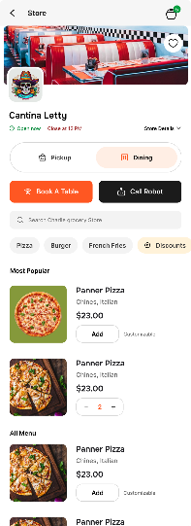

<https://www.instagram.com/p/CsYzfQAAVMb/?hl=en>  
(My day with RTN Smart Pay. Easy and Fast.)  
  
<https://www.instagram.com/p/Cq5-zLMvoh7/?hl=en>

(How many ways you can tap to pay with RTN Smart?)

<https://www.instagram.com/p/Ck8qNzutimP/?hl=en>  
<https://www.instagram.com/p/Cl30iKxN35N/?hl=en>  
(Forget the wallet at home, No need to worry, Easy with RTN Smart QR Pyament. Connect phone, wallet and key. )

<https://www.instagram.com/p/CoLbafLMMN4/?hl=en>

(Struggle to open an online store. With RTN Smart, your online store open within 24 Hours)  
  
<https://www.instagram.com/p/CrzM0nmrvcF/?hl=en>

(When you drop your card at checkout or forget to carry the card, switch to rtn smart qr payment)  
  
<https://www.instagram.com/stories/highlights/17864411177533064/?hl=en>

(Latest Movie, Picture abhi baki hai. Subscribe your fav OTT Platform from RTN Smart Pay…Step by step explain how to do it.)

<https://www.instagram.com/stories/highlights/17905177261893114/?hl=en>

(Have not found the perfect Rakhi gift year)  
  
<https://www.instagram.com/stories/highlights/17927717191569061/?hl=en>

No more change, No more hassle. Scan Pya and go.  
  
<https://www.instagram.com/stories/highlights/17906148110096345/?hl=en>

(Scams related stories we can post and add in highlight like above)

Post: Related to ‘Happy Holiday’ shopping where we can promote the gift card of RTN Smart

<https://www.instagram.com/stories/highlights/17881022072179292/?hl=en>

Post: Related to Refer friends by the concept or idea of weather or rainy season  
  
<https://www.instagram.com/stories/highlights/17848376570397676/?hl=en>

Scan pay go post: With the concept of choosing between 2 things

<https://www.instagram.com/p/DKSegr-St8i/?hl=en>

When you start getting sign of RTN Smart : concept in cloud

<https://www.instagram.com/stories/highlights/17902901686577920/?hl=en>

Puzzle time with fun and games way :   
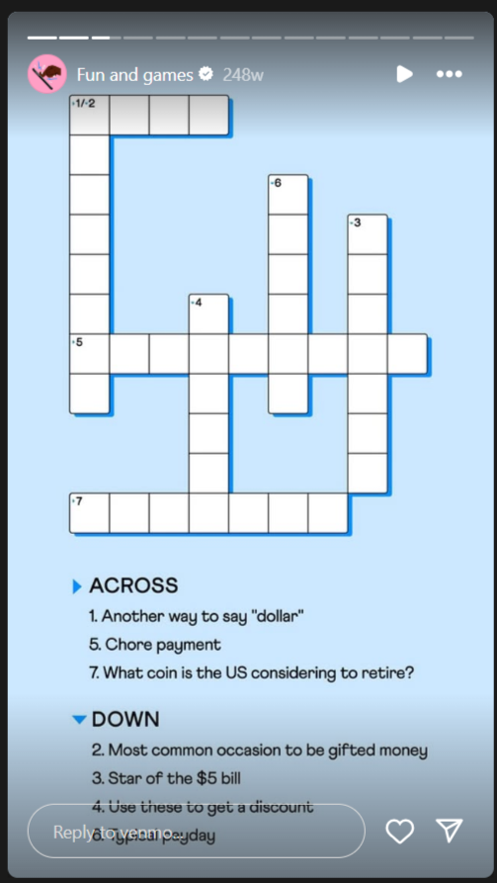

<https://www.instagram.com/p/DGEZsCWPob2/?hl=en&img_index=2>

idea for our rakhi festival post: Send this to your sister.

<https://www.instagram.com/p/C-vQdZBPkM0/?hl=en&img_index=1>

Restaurant: rakhi post idea or we can use this concept in friendship day post too

<https://www.instagram.com/p/CmFK9ScroYX/?hl=en>

Gift card idea used in festive post  
  
<https://www.instagram.com/p/DChaGIBv21a/?hl=en>

I have a lot on RTN Smart plate

Like feature of rtnsmart : C-store, liqure-store, Restaurant, QR Payment

<https://www.instagram.com/p/C3swz5HPU3v/?hl=en>

Five common side hustles : People took up to make more extra money. Visit the link in our bio to see how RTNSmart can help you get started.  
  
<https://www.instagram.com/p/CqY6SeoOFQn/?hl=en>

(For Engagement from comments by brain test)

<https://www.instagram.com/p/CaP6acIvlAi/?hl=en>

Triangle: Loyalty program  
How do you prefer to earn rewards?: A) Punch cards B) Surprise points C) Personalized